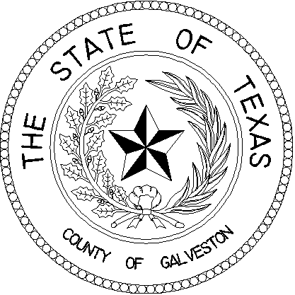

*COUNTY OF GALVESTON*

***Office of Court Administration***

***600 59th Street***

***Galveston, Texas 77551***

***JUDGES MEETING SCHEDULE***

**Thursday, August 19, 2021**

**122nd Jury Deliberation Room, 4th floor of the Galveston County**

**Justice Center, Courts Building**

***_________________________________________________________***

**1:45 p.m. Juvenile Board**

**2:00 p.m. Auditors Board**

**2:15 p.m. Purchasing Board**

**2:30 p.m. Community Supervision & Corrections Board**

**2:45 p.m. Criminal Courts Board**

**3:00 p.m. Galveston County District, County & Probate Judges**