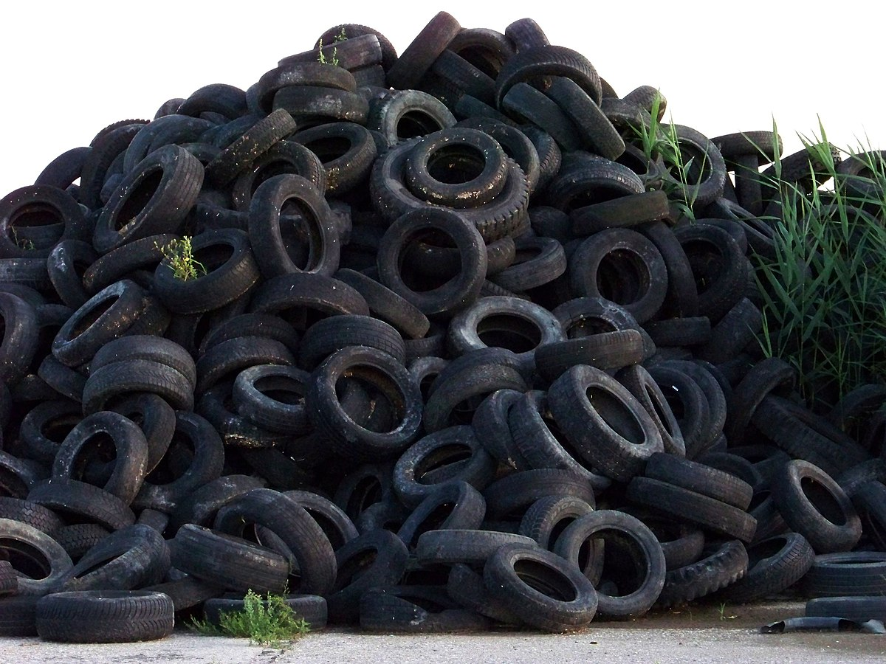

**Tire Disposal**

Precinct Two County Commissioner Joe Giusti, is making available to the citizens of Galveston County an opportunity to dispose of old tires. Collection begins the week of November 18th - November 22nd 2024. The truck will be located in the stock yard adjacent to the West County Building. Hours are from 7:00 to 4:00. You must show proof of Galveston County residency. **Eight tires** **per vehicle** will be accepted. **No commercial or agriculture tires** **will be accepted**. For questions contact:

Yesenia at 409-770-5475