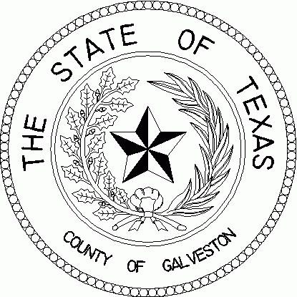

**THE COUNTY OF GALVESTON**

**RUFUS CROWDER, CPPO CPPB ERIN QUIROGA, MBA, CPPB**

PURCHASING AGENT ASSISTANT PURCHASING AGENT

COUNTY COURTHOUSE

722 Moody (21st Street)

Fifth (5th) Floor

Galveston, Texas 77550

(409) 770-5371

**\*NOTICE\***

September 19, 2024

## Board Meeting

**TO:** The Honorable Members of the Purchasing Agent Board

**FROM:** Rufus G. Crowder, CPPO CPPB

Purchasing Agent

County of Galveston

**RE: Purchasing Board Meeting, Thursday, September 26, 2024**

The Purchasing Agent Board will meet on Thursday, September 26, 2024, at 12:00 P.M. at the Galveston County Justice Center located at 600 59th Street in the Justice Center Conference Room located on the 4th floor, room 4100.

**AGENDA ITEMS**

1. **Consideration of Appointment of Purchasing Agent**