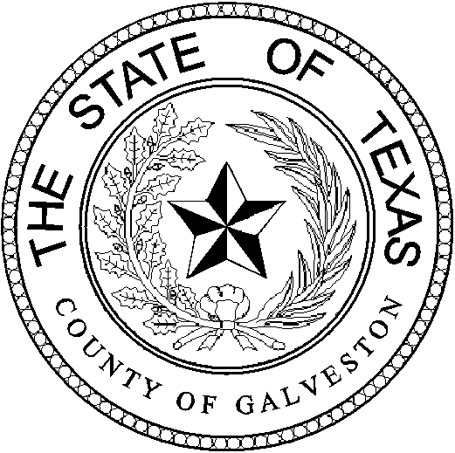

Henry Trochesset, Chairman
Sheriff

Jack Roady, Vice-Chairman
District Attorney

Sean Ferguson, Secretary

Justice of the Peace

Mark Henry
County Judge
Lonnie Cox
Judge, 56th District Court
John Grady
Judge, County Court #1
John Kinard
District Clerk
Dwight Sullivan
County Clerk

Jim Schweitzer
Municipal Judge, City of Galveston
Tammy Stephens
Bail Bond Representative
Rachel Dragony
Defense Attorney

Mike Nelson
Justice of the Peace, Pct 4
John Campbell
Municipal Judge, City of Galveston
Tammy Stephens
Bail Bondsman Representative
GALVESTON COUNTY
BAIL BOND BOARD
5700 AVE H SUITE K212
Galveston, Texas 77551
(409) 766-2263

AGENDA

February 28th, 2024
MEETING TO BE HELD
4th FLOOR CONFRENCE ROOM
1:15 PM

1.) *OPENING AND APPROVAL OF MINUTES*

2.) *NEW BUSINESS:

- Request from Lexington National Ins. DBA: ASAP Bail Bonds AGT: Derrick Dixon; to have Glenda Garcia Mills added as a bond runner.
- Requst from Allegheney Casualty Ins. DBA: Galveston Area Bail Bonds AGT: Louis Jacobo; to have Alaina Nabors added as a runner.
- Request from Troy Mclehany DBA: Bail America to have his licensed renewed.

3.) *OLD BUSINESS: ~Discussion on Bond Forfeitures.

4.) *ADJOURNMENT: @

