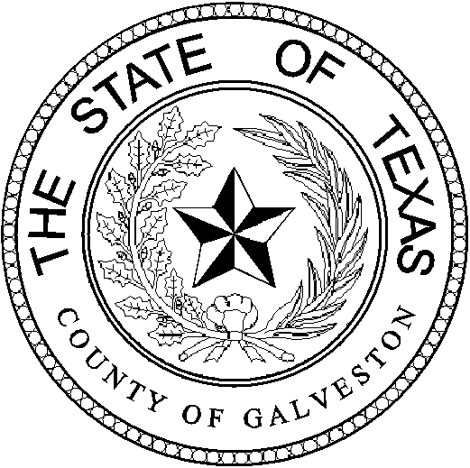

Henry Trochesset, Chairman
Sheriff

Jack Roady, Vice-Chairman
District Attorney

Sean Ferguson, Secretary

Justice of the Peace

Mark Henry
County Judge
Lonnie Cox
Judge, 56th District Court
John Grady
Judge, County Court #1
John Kinard
District Clerk
Dwight Sullivan
County Clerk
Hank Dugie, CPA
County Treasurer
Jim Schweitzer
Municipal Judge, City of Galveston
Tammy Stephens
Bail Bond Representative
Rachel Dragony
Defense Attorney

Mike Nelson
Justice of the Peace, Pct 4
John Campbell
Municipal Judge, City of Galveston
Tammy Stephens
Bail Bondsman Representative
GALVESTON COUNTY
BAIL BOND BOARD
5700 AVE H SUITE K212
Galveston, Texas 77551
(409) 766-2263

AGENDA

January 31st, 2024

MEETING TO BE HELD
4th FLOOR CONFRENCE ROOM
1:15 PM

1.) *OPENING AND APPROVAL OF MINUTES*

2.) *NEW BUSINESS:

- Request from US Fire & INS. Agt. Troy McLehany DBA: HTown Bail Bonds; to have Melina Alcazar added as a runner.
- Request from Troy Mclehany DBA: Bail America to have Melina Alcazar added as a runner.
- Request from Gale Lilliman DBA: Gulf Coast Bail Bonds; to Renew Edward Nichols, Ashley Ward and Francisco Rivera runners.
- Discussion for the November 2023 & December 2023 Bail Bond Board meetings to possibly have the dates moved to more suitable days to avoid possible Quorum conflicts with the Holidays.

3.) *OLD BUSINESS: ~Discussion on Bond Forfeitures.

4.) *ADJOURNMENT: @

