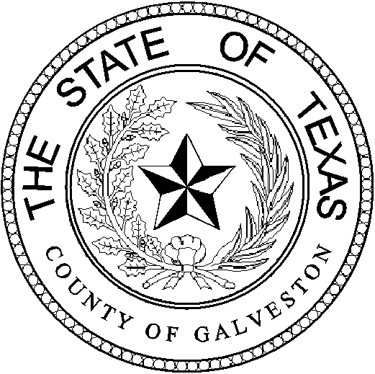

Henry Trochesset, Chairman
Sheriff

Jack Roady, Vice-Chairman
District Attorney

Sean Ferguson, Secretary

Justice of the Peace

Mark Henry
County Judge
Lonnie Cox
Judge, 56th District Court
John Grady
Judge, County Court #1
John Kinard
District Clerk
Dwight Sullivan
County Clerk
Hank Dugie, CPA
County Treasurer
Jim Schweitzer
Municipal Judge, City of Galveston
Tammy Stephens
Bail Bond Representative
Rachel Dragony
Defense Attorney

Mike Nelson
Justice of the Peace, Pct 4
John Campbell
Municipal Judge, City of Galveston
Tammy Stephens
Bail Bondsman Representative
GALVESTON COUNTY
BAIL BOND BOARD
5700 AVE H SUITE K212
Galveston, Texas 77551
(409) 766-2263

AGENDA

July 26, 2023

MEETING TO BE HELD
4th FLOOR CONFRENCE ROOM
1:15 PM

1.) *OPENING AND APPROVAL OF MINUTES*

2.) *NEW BUSINESS:

- Request from Troy McLehany DBA: Bail America; to reconsider the request for Nancy Espinoza to be a runner, due to conflicting data presented in the June 2023 board meeting.
- Request from US Fire & INS. Agt. Troy McLehany DBA: HTown Bail Bonds; to reconsider the request for Nancy Espinoza to be a runner, due to conflicting data presented in the June 2023 board meeting.
- Request from Allegheny Casualty. Agt. Louis Jacobo; DBA: Galveston Area Bail Bonds; to renew their License in Galveston County (2year).
- Request from Bankers Ins. Agt. Angel Lopez; DBA: Better Bail Bonds; to renew their License in Galveston County (3year).
3.) *OLD BUSINESS: ~Discussion on Bond Forfeitures.

4.) *ADJOURNMENT: @

