County and District Clerk’s
SB 6 Presentation

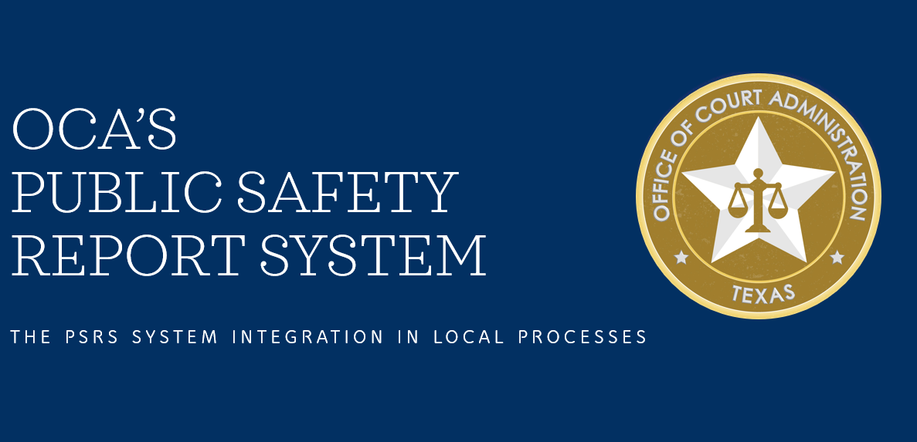

See Powerpoint

Presented by:


SB 6’s Public Safety Report System Information
for
District and County Court Judges

The Second Called Session of the 87th Legislature (2021), enacted Senate Bill 6 which requires the Office of Court Administration (OCA) to develop a statewide Public Safety Report System and requires magistrates who set bail for defendants charged with a Class B misdemeanor or higher category offense to consider a public safety report generated by the Public Safety Report System. The bill also requires any magistrate, judge, sheriff, peace officer or jailer who sets bail under Chapter 17, Code of Criminal Procedure, for a defendant charged with a Class B misdemeanor or higher category offense to complete a bail form and to promptly (but no later than 72 hours) submit it to OCA through the Public Safety Report System.

What does the Public Safety Report System (PSRS) do?
The PSRS serves three primary functions – 1) generates a public safety report with respect to a defendant for magistrates to consider before setting bail for defendants charged with a Class B misdemeanor or higher category offense, 2) provides the bail form that must be completed by magistrates, judges, sheriffs, peace officers and jailers who set bail under Chapter 17, Code of Criminal Procedure, for a defendant charged with a Class B misdemeanor or higher category offense, and 3) provides a system/process for the bail form to be submitted to OCA. (Code of Crim. Proc. Arts. 17.021, 17.022; Gov’t Code Sec. 72.038)

When do I have to consider a public safety report generated by the PSRS or submit a bail form?
Art. 17.022(d) of the Code of Criminal Procedure requires a magistrate setting bail for a defendant charged with a Class B misdemeanor or higher category offense to consider a public safety report generated by the PSRS and to promptly, but no later than 72 hours after setting bail, submit a bail form (Sec. 72.038, Gov’t Code) to OCA using the PSRS.
The following is a guide outlining when a judge is required to consider the public safety report generated by the PSRS and whether a judge needs to complete and submit a bail form using the PSRS:
Activity | Must I Consider a Public Safety Report? | Am I required to submit a bail form?
Performing a 15.17 hearing and setting bail after arrest on a warrant (no indictment, information, or complaint filed) | Yes | Yes
Performing a 15.17 hearing and setting bail after warrantless arrest | Yes | Yes
Determining bail after a 15.17 hearing performed by another magistrate because the judge is the only judge authorized to set bail (b/c of pending felony) | Yes | Yes
Setting a new bail after surety surrender on previous bail | No | Yes
Bond modification - type of bond or amount of bond | No | Yes
Bond revocation without new bond | No | No
Issuing a capias | No | No
Arrest warrant following indictment (new charges) | No | Yes (at time of arrest)
Arrest warrant following indictment (no new charges and no change to originally set bail) | No | No
Arrest warrant following indictment (with change to originally set bail) | No | Yes (at time of arrest)
Warrant for violation of parole/probation (community supervision) | No | Yes (if bail taken after arrest)
Issuing an arrest warrant based on probable cause affidavit | No | No

Are there training requirements imposed by SB 6?
Required Judicial Education - 8-Hour Course Regarding Duties of Magistrates:
Only judges who are in compliance with the judicial education requirements of SB 6 (Art. 17.024, Code of Criminal Procedure) may set bail for a defendant who has been charged with a Class B misdemeanor or higher category offense. Art. 17.024 requires the completion of an 8-hour judicial education course on the duties of a magistrate, including duties with respect to setting bail in criminal cases. After the initial 8-hour training, judges will need to take a 2-hour judicial education course on the duties of a magistrate in each subsequent state fiscal biennium in which the judge serves.(Please note that all Justices of the Peace must take this training regardless of whether they set bail.)
Judges in office on April 1, 2022, have until December 1, 2022 to complete this required judicial education. The Texas Center for the Judiciary will provide training for district and statutory county court judges and the Texas Association of Counties will provide training for constitutional county judges.
Training Required to View/Access Criminal History Information:
In order to generate a public safety report, the Public Safety Report System will be used to access criminal history information from the National Law Enforcement Telecommunications System (NLETS) and the Texas Law Enforcement Telecommunications System (TLETS). This criminal history information will be maintained by the PSRS until the purpose for the information is served. Training requirements regarding access to criminal history will depend on a user’s activity in the PSRS.

Criminal Justice Practitioner Training:
All judges or court staff who access or view hard or electronic copies of criminal history reports are required to obtain and maintain a Criminal Justice Practitioner (CJP) certification. CJP certification can be obtained after a 2-hour self-paced online course provided by the Department of Public Safety (DPS). Recertification is required after two years.
Texas Law Enforcement Telecommunications System (TLETS) Mobile Access Training:
The public safety reports generated by the PSRS will contain full and summary criminal history information on defendants pulled from NLETS and TLETS. Users who prepare public safety reports for judges will need their own individual TLETS user ID so that they can query NLETS and TLETS to obtain a defendant’s criminal history. These users must maintain TLETS Mobile Access Certification. This certification is granted after the completion of an eight-hour live training provided on specific days and times, hosted by DPS with virtual and in-person options. New users have six months to complete the training after initial access to the PSRS is granted. Recertification is required after two years.

For information on how to request access to CJP certification training or TLETS Mobile Access Training or to confirm whether a user’s certification is still valid, please email DPS at TCIC.Training@DPS.Texas.gov.

Additional information regarding the PSRS is available at: https://www.txcourts.gov/programs-services/public-safety-report-system/.

SB 6 Reporting Requirements
- Bail form for Class B and above (Sec. 72.038, Gov’t Code) (p. 34)
- Must be submitted to public safety system by magistrate, judge, sheriff, peace officer or jailer within 72 hours

- Public safety system
- (p.5) Shall be designed to collect and maintain information provided on bail form submitted under Sec. 72.038, Gov’t Code
- (p.6) Before Dec. 1 of each year, OCA shall use the information maintained to collect data from the preceding state fiscal year regarding the number of defendants for whom bail was set after arrest, including
  - Number for each category of offense
  - Number of personal bonds
  - Number of monetary bonds
- Report of delay in review (p. 14)
  - Judge or magistrate must report to OCA each defendant for whom a review was not held within 48 hours of the defendant’s arrest

- Charitable bail organizations (p. 24-5)
  - Charitable bail organization shall submit monthly report to sheriff by 10th of each month for each defendant for whom the organization paid a bail bond
  - Sheriff shall provide copy of the report to OCA
  - Sheriff shall report suspension of any charitable bail organization to OCA
  - Before Dec. 1 of each year, OCA shall prepare a report regarding the information submitted to the office by the sheriffs

- Judicial Council monthly reports (p.33 -34)
- clerk of each court setting bail in criminal cases shall report
1. the number of defendants for whom bail was set after arrest, including:
a. number for each category of offense
b. number of personal bonds and
c. number of surety or cash bonds

2. number of defendants released on bail who subsequently failed to appear
3. number of defendants released on bail who subsequently violated a condition of release and
4. number of defendants who committed an offense while released on bail or community supervision.
- OCA shall post the information in a publicly accessible place on the agency ’s Internet website without disclosing any personal information of any defendant, judge, or magistrate
Before Dec. 1 of each year, OCA shall prepare a report containing the data collected under this section
OTHER Items included in SB6
RESOURCES

District and County Court Judges
The PSRS District and County Court Judges document provides answers and guidance to the following questions:
- What does the PSRS do?
- When do I have to consider a public safety report generated by the PSRS?
- When do I have to submit a bail form?
- Are there training requirements imposed by SB 6?

Procedures and Forms Related to Monetary Bonds
Senate Bill 6 amended Section 17.53 of the Code of Criminal Procedure requiring OCA to develop statewide procedures and prescribe forms to be used by a court to facilitate:
- the refund of any cash funds paid toward a monetary bond, with an emphasis on refunding those funds to the person in whose name the receipt described by Article 17.02 was issued; and
- the application of those cash funds to the defendant’s outstanding court costs, fines, and fees.
The clerk of the court shall make this form available for no charge to the requestor after final disposition of a criminal case.
.
Fees Charged under LGC 117.055 Effective 12/02/2021
- Pursuant to Section 117.055, Local Government Code, to compensate the county for the accounting and administrative expenses incurred in handling the registry funds that have not earned interest, including funds in a special or separate account, the Clerk may deduct a fee equal to 5% of the withdrawal, but not to exceed $50, at the time of refunding a cash bail bond if:
  - Defendant was found guilty at trial or after appeal; or
  - Defendant entered a plea of guilty or nolo contendre and was convicted by the court or placed on deferred adjudication.
- Clerk may NOT deduct the fee if:
  - Defendant was found NOT guilty at trial or after appeal; or
  - The complaint, information or indictment was dismissed without a plea of guilty or nolo contendre being entered.
- If the Clerk deducts a fee before final disposition of the criminal case and the court subsequently makes or enters an order or ruling that would have prohibited the deduction of a fee if it had been entered before the bond was refunded, the Clerk must refund the amount of the deducted fee to the person who requested the refund of the cash bail bond funds. This DOES NOT apply to a dismissal following successful completion of deferred adjudication.

Download here: Motion to Release Funds Deposited for Cash Bail Bond

Charitable Bail Organizations
Sec. 9 (d) of Senate Bill 6 requires that a county clerk issue a certificate to a charitable bail organization, authorizing the organization to pay bail bonds in the county, after the clerk makes certain determinations about the organization. Sec. 9 (e) requires that a charitable bail organization file, in the office of the county clerk where bail bonds are intended to be paid, an affidavit designating the individuals authorized to pay bonds on behalf of the organization. The forms below have been created to assist with these new requirements.

Sample Forms for Courts
- Checklist for Charitable Bail Organization Certificate
- Charitable Bail Organization Certificate Application
- Charitable Bail Organization Certificate
- Affidavit for Bond Payments
Sec. 9 (f) requires that a charitable bail organization submit to the sheriff of the each county, in which the organization filed an affidavit for bond payments, a report that includes information for each defendant the organization paid a bail bond for in the preceding calendar month. The report must be submitted to the sheriff no later than the 10th day of each month.
A sheriff who receives a report from a charitable bail organization shall provide a copy of the report to the Office of Court Administration. Copies of these reports can be email to: bail@txcourts.gov with the subject line in the following format:
[County Name] Sheriff Charitable Bail Organization [Month Name] Report

Sample Forms for Sheriffs and Charitable Bail Organizations
Charitable Bail Organization Bail Report

