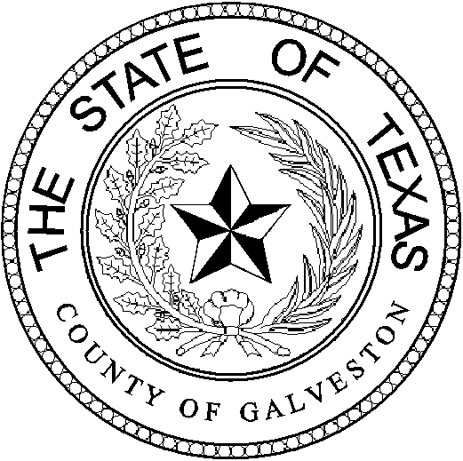

Henry Trochesset, Chairman
Sheriff

Jack Roady, Vice-Chairman
District Attorney

Sean Ferguson, Secretary

Justice of the Peace

Mark Henry
County Judge
Lonnie Cox
Judge, 56th District Court
John Grady
Judge, County Court #1
John Kinard
District Clerk
Dwight Sullivan
County Clerk
Kevin C. Walsh, CPA
County Treasurer
Jim Schweitzer
Municipal Judge, City of Galveston
Tammy Stephens
Bail Bond Representative
Rachel Dragony
Defense Attorney

Mike Nelson
Justice of the Peace, Pct 4
John Campbell
Municipal Judge, City of Galveston
Tammy Stephens
Bail Bondsman Representative
GALVESTON COUNTY
BAIL BOND BOARD
5700 AVE H SUITE K212
Galveston, Texas 77551
(409) 766-2263

AGENDA

October 26, 2022

MEETING TO BE HELD
4th FLOOR CONFRENCE ROOM

1:15 PM

OPENING AND APPROVAL OF MINUTES

NEW BUSINESS

- Request from Lexington National Insurance Corporation. Agent: Wisam Muharib DBA: ALL TX Bail Bonds to conduct business and write bonds in Galveston County as a Corporate Bail Bond Surety.

- (*Pending approval/carry of motion of item A.*) Request from Lexington National Insurance Corporation. Agent: Wisam Muharib DBA: ALL TX Bail Bonds to have Maria Mendoza, Samantha Martinez and Christian Torres added as runners.

- Request from Gulf Coast Bail Bonds to have Yvonne Bonnette renewed as a runner

- Request discussion for the next two Bail Bond Board meetings (November and December) to have dates changed to a more suitable date due to a possible holiday quorum conflict.

OLD BUSINESS:

A Discussion on Bond Forfeitures.

ADJOURNMENT

