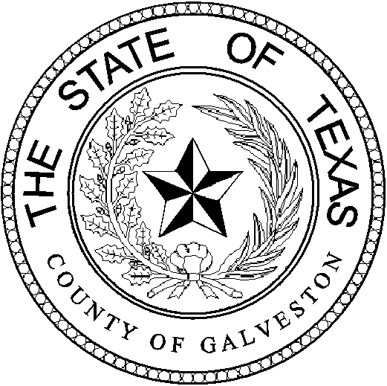

Henry Trochesset, Chairman
Sheriff

Jack Roady, Vice-Chairman
District Attorney

Sean Ferguson, Secretary

Justice of the Peace

Mark Henry
County Judge
Lonnie Cox
Judge, 56th District Court
John Grady
Judge, County Court #1
John Kinard
District Clerk
Dwight Sullivan
County Clerk
Kevin C. Walsh, CPA
County Treasurer
Jim Schweitzer
Municipal Judge, City of Galveston
Tammy Stephens
Bail Bond Representative
Rachel Dragony
Defense Attorney

Mike Nelson
Justice of the Peace, Pct 4
John Campbell
Municipal Judge, City of Galveston
Tammy Stephens
Bail Bondsman Representative
GALVESTON COUNTY
BAIL BOND BOARD
5700 AVE H SUITE K212
Galveston, Texas 77551
(409) 766-2263

AGENDA

JUNE 29, 2022

MEETING TO BE HELD
4th FLOOR CONFRENCE ROOM

1:15 PM

OPENING AND APPROVAL OF MINUTES

NEW BUSINESS

- Request from Jose Espinoza DBA: Affordable Bail Bonds to have property located at AVE H & Mulberry League City, TX (2.92 acres) with appraised value at $80,000 to be released from collateral from Galveston County.

- Request from Gale Lilliman DBA: Gulf coast bail bonds to have Phillip Kochman and Kristi Newman added as new runners and to have Sabrina Stuart, Tanya Jackson and Sandra Vega renewed as current runners.

- Request from Rosemary Dominguez DBA: Budget Bail Bonds to have Henry Abalos added as a runner.

- Request from Bankers Insurance AGT: Angel Lopez DBA: Better Bail Bonds to have Kandess Stepanski, Darren Greene and Monica Ramos added as new runners.

- (*tabled from May Agenda*) Request from Lexington National Insurance Corporation. Agent: Derrick Dixon DBA: ASAP Bail Bonds to conduct business and write bonds in Galveston County as a Corporate Bail Bond Surety.

- (*Pending approval/carry of motion of item E.*) Request from Lexington National Insurance Corporation. Agent: Derrick Dixon DBA: ASAP Bail Bonds to have Gaylon Hyder and Rachel Thomas added as runners.

OLD BUSINESS

A Discussion on Bond Forfeitures.

ADJOURNMENT

