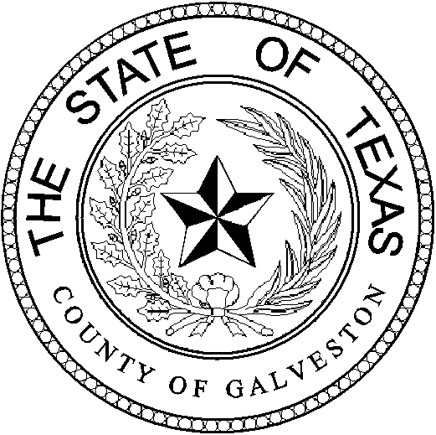

Henry Trochesset, Chairman
Sheriff

Jack Roady, Vice-Chairman
District Attorney

Sean Ferguson, Secretary

Justice of the Peace

Mark Henry
County Judge
Lonnie Cox
Judge, 56th District Court
John Grady
Judge, County Court #1
John Kinard
District Clerk
Dwight Sullivan
County Clerk
Kevin C. Walsh, CPA
County Treasurer
Jim Schweitzer
Municipal Judge, City of Galveston
Tammy Stephens
Bail Bond Representative
Rachel Dragony
Defense Attorney

Mike Nelson
Justice of the Peace, Pct 4
John Campbell
Municipal Judge, City of Galveston
Tammy Stephens
Bail Bondsman Representative
GALVESTON COUNTY
BAIL BOND BOARD
5700 AVE H SUITE K212
Galveston, Texas 77551
(409) 766-2263

AGENDA

APRIL 27, 2022

MEETING TO BE HELD
4th FLOOR CONFRENCE ROOM

1:15 PM

OPENING AND APPROVAL OF MINUTES

NEW BUSINESS

- Request from Gale Lilliman DBA Gulf Coast Bail Bonds to have Mikal McClendon JR. added as a runner.

- Request from Financial Casualty & Surety Insurance Agent: Sheba Muharib DBA: Aable Bail Bonds to have Lenox Beckford added as a runner.

- Request from Rosemary Dominguez DBA: Budget Bail Bonds to have Ringo Hernandez and Jerome Cordova added as runners.

OLD BUSINESS

A Discussion on Bond Forfeitures.

ADJOURNMENT

