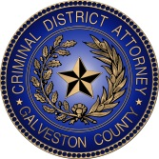

**2022 National Crime**

**Victims’ Rights Week**

**5K Walk/Run**

**“*Rights, access, equity, for all victims***

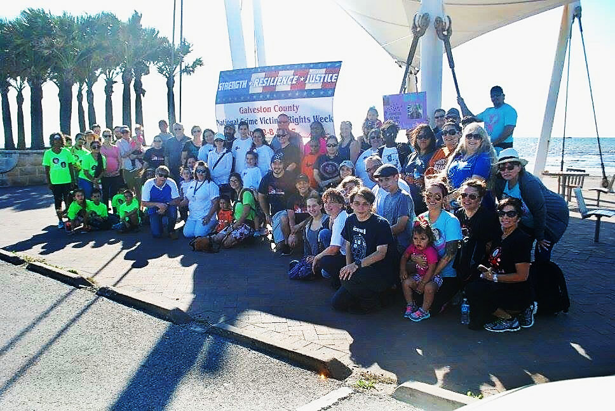

**Saturday April 30, 2022 at 8:00 a.m.**

**45th and Seawall Blvd, Galveston Island**

Participants are welcome to bring banners or

wear T-shirts that honor crime victims.

**For information: Linda Telfah, Chief of Victim Assistance Division**

**Galveston County District Attorney’s Office**

**409-770-5124**