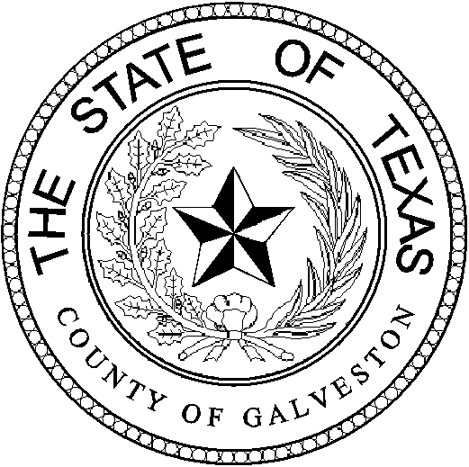

Henry Trochesset, Chairman
Sheriff

Jack Roady, Vice-Chairman
District Attorney

Sean Ferguson, Secretary

Justice of the Peace

Mark Henry
County Judge
Lonnie Cox
Judge, 56th District Court
John Grady
Judge, County Court #1
John Kinard
District Clerk
Dwight Sullivan
County Clerk
Kevin C. Walsh, CPA
County Treasurer
Jim Schweitzer
Municipal Judge, City of Galveston
Tammy Stephens
Bail Bond Representative
Rachel Dragony
Defense Attorney

Mike Nelson
Justice of the Peace, Pct 4
John Campbell
Municipal Judge, City of Galveston
Tammy Stephens
Bail Bondsman Representative
GALVESTON COUNTY
BAIL BOND BOARD
5700 AVE H SUITE K212
Galveston, Texas 77551
(409) 766-2263

AGENDA

February 23, 2022

MEETING TO BE HELD
4th FLOOR CONFRENCE ROOM

1:15 PM

OPENING AND APPROVAL OF MINUTES

NEW BUSINESS

A Request from Troy Mclehany DBA: Bail America to release the following pledged properties at 1.) 2121 Laguna Harbor Cove, Port Bolivar, TX, 77650….$70,000 and 2.) Lot 1, West half sect 11, IGNRR Abst 599, Galveston County, Galveston, TX (3.6 ac)…$72,000.

OLD BUSINESS

A Discussion on Bond Forfeitures.

ADJOURNMENT

