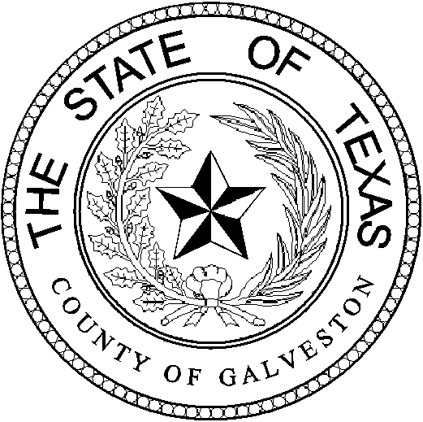

Henry Trochesset, Chairman
Sheriff

Jack Roady, Vice-Chairman
District Attorney

Ray Davis, Secretary

Justice of the Peace

Mark Henry
County Judge
Lonnie Cox
Judge, 56th District Court
John Grady
Judge, County Court #1
John Kinard
District Clerk
Dwight Sullivan
County Clerk
Kevin C. Walsh, CPA
County Treasurer
Jim Schweitzer
Municipal Judge, City of Galveston
Tammy Stephens
Bail Bond Representative
Rachel Dragony
Defense Attorney

Mike Nelson
Justice of the Peace, Pct 4
John Campbell
Municipal Judge, City of Galveston
Tammy Stephens
Bail Bondsman Representative
GALVESTON COUNTY
BAIL BOND BOARD
5700 AVE H SUITE K212
Galveston, Texas 77551
(409) 766-2263

AGENDA

October 27, 2021

MEETING TO BE HELD
4th FLOOR CONFRENCE ROOM

1:15 PM

OPENING AND APPROVAL OF MINUTES

NEW BUSINESS

A Request from Gale Lilliman DBA: Gulf Coast Bail Bonds to renew the following employees, Gabriell Rodriguez, Francisco Rivera, and have Ashley Ward, Elizabeth Rojas, Chelsey Lage, Jose Longoria Jr. added as new runners.

B Request from Financial Casualty & Surety DBA: AABLE Bail Bonds. Agent: Sheba Muharib to add the following employee, Claudia Covarrubias as a runner.

C Request from Bankers Insurance DBA: Better Bail Bonds. Agent Angel Lopez to
Have Francisco Rodriguez Rojas added as a runner.

D
Request from US Fire & Insurance DBA: HTOWN Bail Bonds. Agent Troy
McLehany to have Valerie Torres and Marissa Morgan added as runners.

E Request from Tammy Stephens DBA: League City Bail Bonds to renew her license.

F Request to have the November meeting moved to the 17th due to last Wednesday falling the day before Thanksgiving.

OLD BUSINESS

A Discussion on Bond Forfeitures.

ADJOURNMENT

